Touch Sensor interrupt with Blue Pill using STM32CubeIDE

**Prerequisites**

This project assumes you have already installed STM32CubeIDE. You need to have previously done a basic blink sketch with blue-pill using STM32CubeIDE. I have made a complete video from installing STM32CubeIDE to LED blink program. You can watch it by clicking this link. <https://www.youtube.com/watch?v=kXg467nVd_A>

**Wiring Diagram**

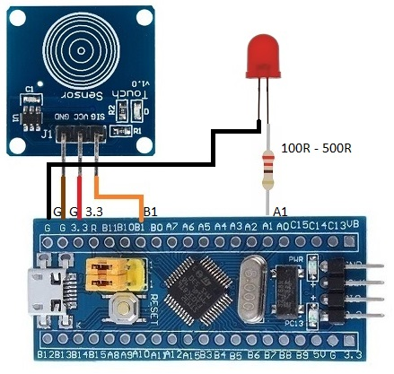

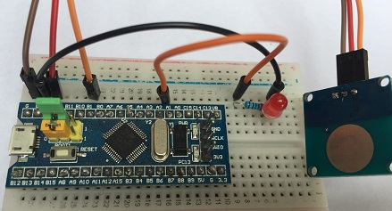

**STM32CubeIDE Settings**

Set PA1 to GPIO_Output

Set PB1 to GPIO_EXTI1

Click NVIC → EXTI line1 interrupt → Enabled (Tick)

**Additional code on top of STM32CubeIDE generated code**

/* USER CODE BEGIN 4 */

**void** HAL_GPIO_EXTI_Callback(uint16_t GPIO_Pin)

{

**if** (GPIO_Pin == GPIO_PIN_1)

{

HAL_GPIO_TogglePin(GPIOA, GPIO_PIN_1);

}

}

/* USER CODE END 4 */